Lloyd Center Ice Rink

Spring Challenge 2011

USFS Basic Skills Invitational Competition

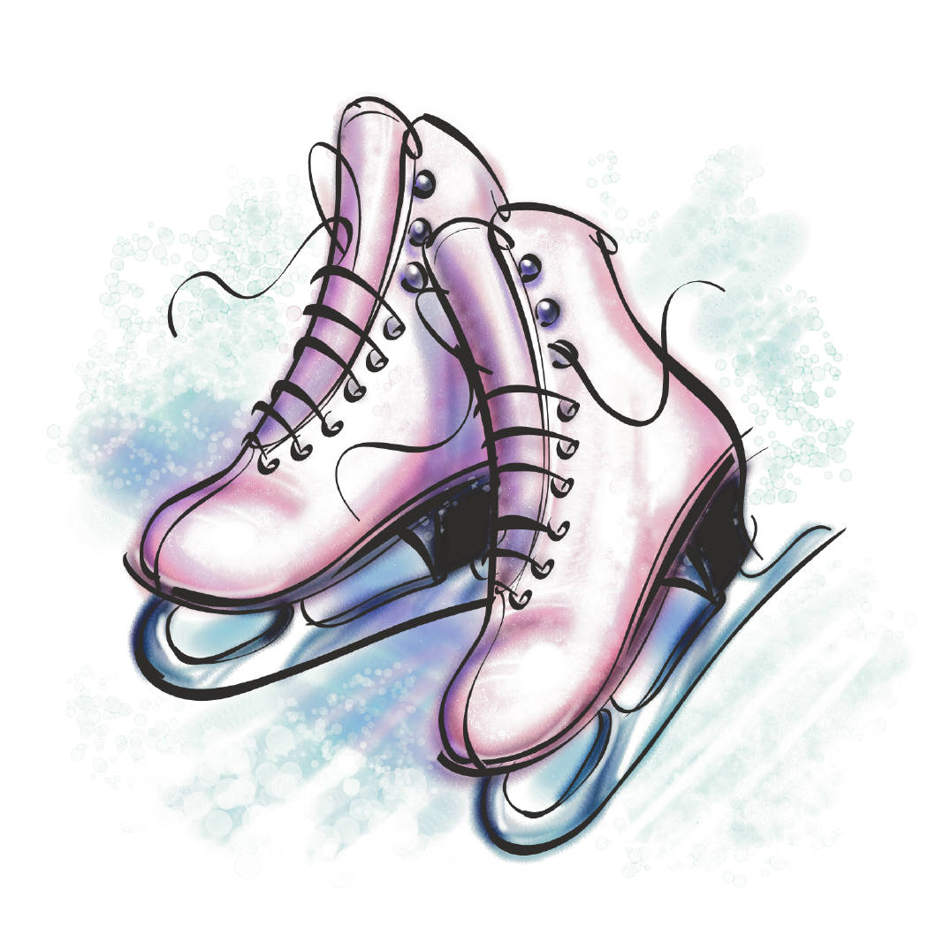

May 21st and 22nd, 2011

Lloyd Center Ice Rink

953 Lloyd Center

Portland, OR 97232

Phone: (503) 288-6073

Fax: (503) 288-6940

**Lloyd Center Ice Rink**

**USFS Basic Skills Open Competition**

**May 21st & 22nd, 2011**

USFS Approval

Dear USFS Clubs

We cordially invite you to attend our Spring Challenge USFS Basic Skills Open Competition that will be held at Lloyd Center Ice Rink in Portland, Oregon.

Lloyd Center Ice Rink is a single-surface facility that is located in the heart of the Lloyd Center Mall in Portland, Oregon. The Lloyd Center Mall offers great shopping, restaurants, and entertainment within walking distance of our rink and is connected to Max (the Metropolitan Area Express, Portland’s light rail service) for easy access to downtown shopping and fine dining.

Enclosed in this announcement are entry forms and information about our competition. We have separated the Announcement into sections for ISI and USFS to avoid any confusion. (The ISI and USFS events will be scheduled at different times to avoid confusion due to the differences in the judging and accounting requirements of each association.)

**The postmark deadline for all entry forms is Sunday, May 1st, 2011**. Late entries, if accepted, will be charged double. If you have any questions, please contact Lloyd Center Ice Rink at (503) 288-6073. A complete schedule will be sent to each participating rink approximately two weeks prior to the start of the competition.

We look forward to seeing you!

Respectfully,

Christy Ward

Competition Director / Chief Referee **Please send all forms to:**

***Lloyd Center Ice Rink***

***Attn: Competition Director***

***953 Lloyd Center***

***Portland, OR 97232***

**General Competition Information**

**Competition Dates:** May 21st & 22nd, 2011

**Entry Form Postmark Deadline:**  Sunday, May 1st, 2011

Late entries, if accepted, will be charged double. There will be a $10 fee to change your entered events after the deadline.

**Rink Address:**

Lloyd Center Ice Rink

953 Lloyd Center

Portland, OR 97232

**Verification:** The information on the entry form must be accurate and complete. Inaccurate and / or

incomplete forms will be returned. False information will result in disqualification.

Payment is due when the entry form is submitted. There will be a $10.00 fee for any

changes made to your original entry form.

**Hospitality:** There will be a hospitality area open to all judges, coaches, and volunteers.

**Age Groups:** Will be determined by the number of entries in each level.

**Music and Registration:**  All skaters are to check in at the registration desk at least 1 hour prior to

the scheduled event. If the competition is running ahead of schedule, an event may

begin earlier than the scheduled time. Events will NOT be held for late skaters, and no

refund will be given if a skater misses the event. CD’s should be turned in at check-in.

Music will be available for pick-up within one hour following the event. CD’s are to be

clearly labeled with the skater’s name, level, event, and the rink they represent. There

should be no more than one program on a CD. Be sure to bring a back-up CD. No

cassette tapes are allowed.

**Awards:** All skaters will receive an award. Awards will be presented when the results of that event are posted.

**Rink Size:** The ice surface is 176‘ x 76‘

**Practice Ice:** A schedule for practice ice will be mailed to each rink and posted on our website at www.lloydcenterice.com by May 9, 2011.

**Schedule of Events:** A preliminary schedule of events will be sent to each participating rink

approximately two weeks prior to the competition.

**Refunds:** No refunds will be granted after the close of entries unless submitted with a doctor’s

note.

**Lloyd Center Ice Rink**

**Spring Challenge 2011**

**USFS Basic Skills Open Competition**

**May 21st & 22nd, 2011**

**Include a Love Line to someone special in our competition program**

**Only $5 !!!!**



Please fill out and return with your payment (25 words or less).

Skater’s Name: _______________________________________

Message: ____________________________________________

____________________________________________________

____________________________________________________

Love Lines must be received by Sunday, May 1, 2011 in order to be included in our program.

**Suggestion: Send it in with your entry form – that way you won’t forget.**

*Please make checks payable to Lloyd Center Ice Rink and mail to:

***Lloyd Center Ice Rink***

***Attn: Competition Director***

***953 Lloyd Center***

***Portland, OR 97232***

Lloyd Center Ice Rink

Spring Challenge 2011

USFS Basic Skills Open Competition

May 21st and 22nd, 2011

Here’s your opportunity to highlight your business to the skaters and their families during our upcoming competition. If you have a product or service you would like to promote, please place an ad in our commemorative program.

Thank you in advance for your support.

Program Ad Prices

* 1 Line …………………………………………………………………………… $ 5.00
* Business Card ……………………………………………………………… $ 25.00
* ¼ Page ………………………………………………………………………… $ 35.00
* ½ Page ………………………………………………………………………… $ 60.00
* Full Page ……………………………………………………………………… $ 100.00

Please fill out and return with your payment.

Name of Company:___________________________________________________

Ad Size: _________________ Total Amount Due: _________________________

**\*Please make checks payable to Lloyd Center Ice Rink and include your artwork.**

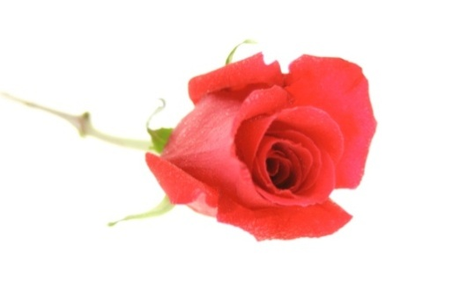Lloyd Center Ice Rink

953 Lloyd Center

Portland, OR 97232

(503) 288-6073

**Directions to Lloyd Center Ice Rink**

The Lloyd Center Mall is located approximately ½ mile east of I-5. We are located in the center of the mall on the 1st level next to Macy’s. The streets surrounding the Lloyd Center Shopping Center are NE Halsey St, NE 15th Ave., NE Multnomah St., and NE 9th Ave.

**Driving Directions**

**From the North of Portland**

* Take I-5 South toward Portland
* Take EXIT 302A toward ROSE QUARTER / CITY CENTER
* Take the ramp toward ROSE QTR
* Turn LEFT onto NE WEIDLER ST
* Turn RIGHT onto NE 14TH AVE
* Turn RIGHT onto NE HALSEY ST / LLOYD CTR

**From the South of Portland**

* Take I-5 North toward Portland
* Take EXIT 302A toward ROSE QUARTER / BROADWAY-WEIDLER ST
* Turn RIGHT onto NE WEIDLER ST
* Turn RIGHT onto NE 14TH AVE
* Turn RIGHT onto NE HALSEY ST / LLOYD CTR



**From the East of Portland**

* Take I-84 West toward Portland
* Take the LLOYD CENTER exit, EXIT 1
* Keep RIGHT at the fork to go on NE 13TH AVE
* Turn RIGHT onto NE MULTNOMAH ST

**List of Area Hotels / Motels**

Lloyd Center Ice Rink is conveniently located in the center of the Lloyd Center Mall. There are many hotels and motels to choose from in close proximity to the mall. Listed below are some of the local accommodations.

Doubletree Hotel

1000 NE Multnomah St

Portland, OR 97232

(503) 281-6111

<http://doubletree1.hilton.com>

Residence Inn Portland Downtown / Lloyd Center

1710 NE Multnomah St

Portland, OR 97232

(503) 288-1400

[www.marriott.com/hotels/travel/pdxlc](http://www.marriott.com/hotels/travel/pdxlc)

Red Lion Hotel Portland

1021 NE Grand Ave

Portland, OR 97232

(503) 235-2100

<http://redlion.rdln.com/HotelLocator/HotelOverview.aspx?metaID=38>

Courtyard Hotel Downtown Portland at Lloyd Center

435 NE Wasco St

Portland, OR 97232

(503) 234-3200

<http://www.marriott.com/hotels/travel/pdxcl-courtyard-portland-downtown-lloyd-center>

LaQuinta Inn Portland Convention Center

431 NE Multnomah St

Portland, OR 97232

(503) 233-7933

<http://www.lq.com/lq/properties/propertyProfile.do?ident=LQ462&propId=462>

Inn at the Convention Center

420 NE Holladay St

Portland, OR 97232

(503) 233-6331

<http://www.innatcc.com/info.html>

**USFS Basic Skills Events**



**USFS Basic Skills Event Information**

**ELIGIBILITY:**

The USFS Basic Skills events in this competition are open to all skaters who are current eligible

(ER 1.0) members of either the Basic Skills Program and / or are current full members of

U.S Figure Skating. To be eligible, skaters must have submitted a membership application or be a member in good standing. Members of other organizations are eligible to compete but must be registered with the host Basic Skills Program / Club or any other Basic Skills Program / Club.

USFS event eligibility will be based on skill level as of May 1, 2011 (the closing day for

entries.) All SNOWPLOW SAM and BASIC SKILLS levels BASIC 1 – BASIC 8 must skate at the

highest level passed or one higher level, and NO official US Figure Skating tests may have been

passed including MIF (Moves in the Field) or Individual Dances. Skaters in other USFS events

may skate at the highest Free Skate level passed OR one level higher BUT not both levels in the

same event during the same competition.

USFS membership and eligibility will be verified. If, for whatever reason, the Competition

Organizing Committee discovers that a skater has been placed in an incorrect level, the Chair

and Referee will have the option to move the skater into the proper level, even if this has to be done the day of the competition. This will ensure that every event is as fair as possible to the competitors.

**JUDGING:** The USFS events will be judged according to the rules and regulations set forth in the

U.S. Figure Skating Basic Skills Competition Manual.

There will be a hospitality area open to all judges, coaches, and volunteers.

**RULES:**

The USFS events in this competition will be conducted in accordance with the 2010-2011 US

Figure Skating Basic Skills Competition Manual and the 2010-2011 US Figure Skating Rules and

Standards.

j0168598.wmf

**LIST OF USFS BASIC SKILLS EVENTS**

**Basic Elements Event** Snowplow Sam – Basic 8

**Basic Program Event** Snowplow Sam – Basic 8

**Free Skate Elements Event** Free Skate 1 – 6

**Free Skate Event** Free Skate 1 – 6

**Compulsory Event** Limited Beginner – Preliminary

**Well-Balanced Program**  No Test – Preliminary

**Showcase Events** Snowplow Sam – Preliminary

**Interpretive Events** Snowplow Sam – Preliminary



**Showcase Events**

* Skaters should enter at their free skate level
* Divided into age and level categories as entries warrant
* Theme of skater’s choice
* May have music with words
* Judging to emphasize entertainment value and interpretation of music rather than technical skills
* Costumes to complement music
* May use hand props or any items that skater can get on and off the ice without assistance within 30 seconds.
* Program Time: up to 1:30 +/- 10 seconds

*************************************************************************************

**Interpretive Events**

**Competition Rules:** The Organizing Committee will pre-select music for the Interpretive events. All

skaters in an event will skate to the same music. Skaters will have the chance to

hear the music selection twice during the warm-up. Following the warm-up, all

skaters except for the first skater will be escorted to a soundproof locker room or other area to await their turn to skate. Skaters will hear the music one more time before they skate their program.

**Levels:** The Interpretive Events are open to all U.S. Basic Skills and U.S. Figure Skating members

through the Preliminary level. Skaters should enter at their free skate level. Each event

group will be broken by age and ability as warranted by the entries received. Male and

female skaters may be combined.

**Judging Rules:** Skaters are judged on originality, music interpretation / expression, pattern, variety of

moves used, and creativity. Jumps and spins performed must be appropriate to the

competition level.

**Coaching Rules:**  There is no instruction allowed during this event from coaches, parents, or other

skaters. Staging area must be kept clear except for Ice Monitor and authorized

competition personnel.

|  |  |
| --- | --- |
| **Snowplow Sam:**   1. March followed by a two foot glide and dip 2. Forward two foot swizzles 2-3 in a row 3. Backward wiggles 2-6 in a row 4. Forward snowplow stop | **Basic 5:**   1. Backward outside edge on a circle clockwise or counterclockwise 2. Backward crossovers 4-6 consecutive - both directions 3. Basic one foot spin – free leg held to side of spinning leg - minimum three revolutions 4. Side toe hop -either direction 5. Hockey stop |
| **Basic 1**   1. Forward two foot glide and dip 2. Forward two foot swizzles 6-8 in a row 3. Backward wiggles 6-8 in a row 4. Forward snowplow stop | **Basic 6:**   1. Standstill forward inside three-turn - R & L 2. Bunny Hop 3. Forward spiral on a straight line - R or L 4. Lunge - R or L 5. T-stop - R or L |
| **Basic 2**   1. Forward one foot glide - either foot 2. Forward alternating ½ swizzle pumps, in a straight line – 2-3 each foot 3. Two foot turn in place- forward to backward 4. Backward two foot swizzles 6 - 8 in a row 5. Moving snowplow stop | **Basic 7:**   1. Forward inside open Mohawk - R to L and L to R 2. Ballet Jump - either direction 3. Back crossovers to a back outside edge landing position clockwise and counter clockwise 4. Forward inside pivot |
| **Basic 3**  1. Forward stroking  2. Forward ½ swizzle pumps on a circle, either  clockwise or counter clockwise 4-6 consecutive   1. Backward one foot glide - either foot 2. Forward slalom 3. Two foot spin – minimum three revolutions | **Basic 8:**   1. Moving forward outside or forward inside three-turns R & L 2. Waltz jump 3. Mazurka - either direction   4. 1 Combination move - clockwise or counter clockwise – two forward crossovers into FI Mohawk, step down, cross behind, step into one back crossover and step to a forward inside edge  5. Beginning one-foot upright spin – free foot held to side of spinning leg or crossed position -minimum three revolutions |
| **Basic 4**   1. Standstill forward outside three-turn - R & L 2. Forward outside edge on a circle clockwise or counter clockwise 3. Forward crossovers 4-6 consecutive both directions 4. Backward stroking - 4-6 strokes   5. Backward snowplow stop - R or L |  |

# Basic Elements Event: SNOWPLOW SAM – BASIC 8

Each skater will perform each element when directed by a judge or referee or have the option to perform one element at a time in the order listed below (no excessive connecting steps)

* To be skated on 1/2 ice
* No music
* **All elements must be skated in the order listed**
* Time: 1:00 or less

**BASIC PROGRAM EVENT: SNOWPLOW SAM – BASIC 8**

The skating order of the required elements is optional. The elements are not restricted as to the number of times the element is executed or length of glides, number of revolutions, etc. unless otherwise specified. Vocal music is allowed.

* To be skated on full ice
* Time: 1:00 +/- 10 seconds
* The skater may use elements from a previous level
* A .2 deduction will be taken for each element performed from a higher level

|  |  |
| --- | --- |
| **Snowplow Sam:**  1. March followed by a two foot glide and dip  2. Forward two foot swizzles 2-3-in a row  3. Backward wiggles 2-6 in a row  4. Forward snowplow stop | **Basic 5:**  1. Backward crossovers 4-6 consecutive in both directions  2. Basic one-foot spin – free leg held to side of spinning leg - minimum three revolutions  3. Side toe hop -either direction  4. Hockey stop |
| **Basic 1**  1. Forward two foot glide and dip  2. Forward two foot swizzles 6 -8 in a row  3. Backward wiggles 6-8 in a row  4. Forward snowplow stop | **Basic 6:**  1. Standstill forward inside three-turn - R & L  2. Bunny Hop  3. Forward arabesque spiral on a straight line R or L  4. Lunge - R or L  5. T-stop - R or L |
| **Basic 2**  1. Forward one foot glide - either foot  2. Two foot turn in place- forward to backward  3. Backward two foot swizzles 6 - 8 in a row  4. Forward alternating ½ swizzle pumps, in a straight line – 2-3 each foot  5. Moving snowplow stop | **Basic 7:**  1. Forward inside open Mohawk - R to L and L to R  2. Ballet Jump- either direction  3. Back crossovers to a back outside edge landing position clockwise and counter clockwise  4. Forward inside pivot |
| **Basic 3**  1. Forward stroking  2. Forward ½ swizzle pumps on a circle, either  clockwise or counter clockwise 4-6 consecutive  3. Backward one foot glide – either foot  4. Forward slalom  5. Two foot spin – minimum three revolutions | **Basic 8:**  1. Moving forward outside or forward inside three-turns R & L  2. Waltz jump  3. Mazurka in either direction  4. 1 Combination move - clockwise or counter clockwise - two forward crossovers into FI Mohawk, step down, cross behind, step into one back crossover and step to a forward inside edge  5. Beginning one-foot upright spin - free foot held to side of spinning leg or crossed position -minimum three revolutions |
| **Basic 4**  1. Forward crossovers 4-6 consecutive both directions  2. Standstill forward outside three- turn - R & L  3. Backward stroking - 4-6 strokes  4. Backward snowplow stop - R or L |  |

# Free SKATE 1-6 COMPULSORY EVENT

In simple program form, using a limited number of connecting steps, the skating order of the required elements is optional

* To be skated on ½ ice
* No music is allowed
* The skater must demonstrate the required elements and may use any additional elements from previous levels
* A .2 deduction will be taken for each element performed from a higher level
* Time: 1:15 or less

|  |  |
| --- | --- |
| **Free skate 1 Compulsory**   1. Advanced forward stroking - 4-6 consecutive 2. Basic forward outside edges and forward inside consecutive edges - 2-4 outside and 2-4 inside 3. One-foot upright scratch spin from backward crossovers-minimum three revolutions 4. Waltz jump from backward crossovers   5. Half flip jump | **Free skate 4 Compulsory**   1. Forward power 3's, 2-3 consecutive sets-R or L 2. Sit spin- minimum three revolutions 3. Loop jump 4. Waltz jump/loop jump |
| **Free skate 2 Compulsory**   1. Forward outside or inside spiral - R or L 2. Waltz Three's - R or L, 2-3 sets 3. Beginning back spin - entry optional 4. Waltz jump, side toe hop, waltz jump series 5. Toe loop jump | **Free skate 5 Compulsory**   1. Camel spin- minimum three revolutions 2. Forward upright spin to back upright spin- minimum three revolutions, each foot 3. Loop/loop jump 4. Flip jump |
| **Free skate 3 Compulsory**   1. Forward crossovers in a figure 8 2. Advanced forward outside swing rolls 4 - 6 consecutive 3. Back spin- minimum three revolutions 4. Salchow jump 5. Waltz jump/toe loop or Salchow/toe loop | **Free skate 6 Compulsory**   1. Five step Mohawk sequence - 1 set alternating pattern (refer to Basic Skills Curriculum Free skate 6) 2. Camel, sit spin combination - minimum of four revolutions total 3. Split jump or stag jump 4. Waltz jump, ½ loop, Salchow combination   5. Lutz jump |

Free SKATE 1-6 - FREESKATE EVENT

The skating order of the required elements is optional. The elements are not restricted as to the number of times element is executed, or length of glides, number of revolutions, etc. unless otherwise stated. Vocal music is allowed.

* The skater must demonstrate the required elements and may use but is not required to use any additional elements from previous levels
* A .2 deduction will be taken for each element performed from a higher level
* Time 1:30+/-10sec

|  |  |
| --- | --- |
| **Free skate 1** | **Free skate 4** |
| 1. Advanced forward stroking 4-6 strokes  2. One-foot upright scratch spin from back crossovers- minimum three revolutions  3. Waltz jump from back crossovers  4. Half flip jump | 1. Forward power 3’s, 2-3 consecutive R or L  2. Sit spin-minimum three revolutions  3. Loop jump  4. Waltz jump/loop jump |
| **Free skate 2** | **Free skate 5** |
| 1. Forward outside spiral R or L  2. Beginning back spin  3. Waltz jump, side toe hop, waltz jump  4. Toe loop | 1. Camel spin-minimum three revolutions  2. Forward upright spin to back upright spin- minimum three revolutions each foot  3. Loop/loop combination jump  4. Flip jump |
| **Free skate 3** | **Free skate 6** |
| 1. Forward crossovers in a figure 8  2. Back spin-minimum three revolutions  3. Salchow  4. Waltz jump/Toe loop or Salchow/toe loop | 1. Camel/sit spin combination-minimum four revolutions total  2. Split or stag jump  3. Waltz jump/1/2 loop /Salchow combination  4. Lutz jump |

**Lloyd Center Ice Rink**

**Spring Challenge**

**USFS Basic Skills Open Competition**

**May 21st & 22nd, 2011**

___________________________________ __________________ ________________________

Name Phone Alternate Phone

___________________________________ _________________ _____________ ___________

Address City State Zip

Female / Male (circle) ______________ ___________ _______________________________

Age on 05/01/2011 Birth Date Email Address

Highest Levels Passed: ________________ ______________ ________________________

Basic Skills Free Skate Moves in the Field

_____________________________ ___________ __________________ ___________________

USFS Club or Basic Skills Program USFS Number Coach’s Name Coach’s Phone

**Please check the event(s) you are entering:**

**Basic Skills:** **Free Skate Elements: Compulsory:**

__ Snowplow Sam __ Free Skate 1 __ Limited Beginner

__ Basic 1 __ Basic 5 __ Free Skate 2 __ Beginner

__ Basic 2 __ Basic 6 __ Free Skate 3 __ No Test

__ Basic 3 __ Basic 7 __ Free Skate 4 __ Pre-Preliminary

__ Basic 4 __ Basic 8 __ Free Skate 5 __ Preliminary

__ Free Skate 6

**Basic Program: Free Skate: Well-Balanced Program:**

__Snowplow Sam __Free Skate 1 __No Test

__Basic 1 __Basic 5 __Free Skate 2 __Pre-Preliminary

__Basic 2 __Basic 6 __Free Skate 3 __Preliminary

__Basic 3 __Basic 7 __Free Skate 4

__Basic 4 __Basic 8 __Free Skate 5

__Free Skate 6

**Showcase: Interpretive:**

__Snowplow Sam __Snowplow Sam

__Basic 1 __Basic 5 __Basic 1 __Basic 5

__Basic 2 __Basic 6 __Basic 2 __Basic 6

__Basic 3 __Basic 7 __Basic 3 __Basic 7

__Basic 4 __Basic 8 __Basic 4 __Basic 8

__Free Skate 1 __Free Skate 5 __Free Skate 1 __Free Skate 5

__Free Skate 2 __Free Skate 6 __Free Skate 2 __Free Skate 6

__Free Skate 3 __Free Skate 7 __Free Skate 3 __Free Skate 7

__Free Skate 4 __Free Skate 8 __Free Skate 4 __Free Skate 8

__No Test __No Test

__Pre-Preliminary __Pre-Preliminary

__Preliminary __Preliminary

**USFS Basic Skills Open Competition – continued**

**Certification of the Competitor**

The competitor is eligible to enter the event(s) checked. It is agreed that the competitor skates this competition at his / her own risk. The competitor and family hereby release Lloyd Center Ice Rink, Skating Club of Oregon, participating rinks, their personnel, and contractors from all liabilities. The competitor and family also agree that any photographs or videos taken by ISI, USFS, Lloyd Center Ice Rink, or any authorized party may be used by ISI, USFS or Lloyd Center Ice Rink for promotional purposes.

Competitor Signature: ____________________________________ Date: _________________

Parent / Guardian Signature: _______________________________ Date:__________________

Instructor / Coach Signature: _______________________________ Date: ________________

Club Officer / Program Director Signature: _____________________ Date:_________________

Entry Fee is $50 for the First USFS Event, $20 for each additional event

First Event $50 $ ________________

Each Additional Event $20 x # of events ____ $ ________________

TOTAL $ ________________

The completed entry form with fees must be postmarked no later than May 1, 2011.

Late entries, if accepted, will be charged double.

Make check or money order payable to Lloyd Center Ice Rink

Returned check fee is $25.00

To pay with a credit card:  Visa  Mastercard

_______________________________ ________________________ _____________________

Credit Card Number Expiration Date 3-Digit Verification Code

______________________________ _________________________________________________

Name on Card (please print) Signature

Mail check and completed entry form to: Lloyd Center Ice Rink

Attn: Competition Director

953 Lloyd Center

Portland, OR 97232